Approach Document for

Task Manager
Version 1.0
CR ID: HBU/Task Manager/



NeST Digital Private Limited
(Formerly NeST Information Technologies Pvt Ltd)

Copyright Notification: | This document is the property of NeST Digital Private Limited (Formerly NeST Information Technologies Pvt Ltd). No part of this document may be reproduced except as authorized by written permission from NeST Digital Private Limited (Formerly NeST Information Technologies Pvt Ltd). The copyright and the foregoing restriction extend to reproduction in all media.
Format ID: | NeST/wFM/257 V2.0

Amendment Record

Version | Date | Author | Reviewed By | Approved By | Change Description
1 | 10/05/2022 | Muhammed Irshad Ch

Table of Contents

1 Purpose and Scope
2 Abbreviations/Definitions
3 Inputs
4 Approach (Mandatory)
4.1 Requirement
4.2 Proposed Solution
4.2.1 Approach 1

Purpose and Scope
Purpose: The purpose of this task is to create a user interface for assigning tasks and task sets to patients in a healthcare application. This will enable healthcare providers to easily manage and assign tasks to patients and keep track of their progress.
Scope: The scope of this task includes creating a left navigation menu that will allow users to navigate to the patient task page. The patient task page will display a list of tasks and task sets that can be assigned to the patient. A new Assign panel will be added on clicking the assign button, which will display information about the task or task set and allow the user to assign it to the patient.

Abbreviations/Definitions
MRN: Medical Reference Number
DOB: Date Of Birth

Inputs

Patient Id
Task Id
Task Set Id
Date And Time Of Assigning task
Date And Time Of Assigning task set

Approach (Mandatory)
DataBase:SQL
FrontEnd:Angular
BackEnd:JavaSpringBoot

The task and task sets will be loaded from the backend and displayed in the patient task page. A plus button will be added to each task and task set item on hovering, which will allow the user to assign it to the patient on clicking it

Requirement
1. Provide a left navigation menu to navigate to patient task
2. Add an assign button to open an assign panel in the right.
3. Load the task and task sets .
4. Add a Plus button on hovering a task / task set item
5. Assign task / task set to the patient on clicking plus button

Proposed Solution
Frontend:
1. A left navigation menu to navigate to patient task
2. An assign button to open an Assign panel in the right.
3. View the task and task sets as A drop down list.
4. A Plus button on hovering a task/task set item
5. Assign task / task set to the patient on clicking plus button

BackEnd:

To support the frontend features, created some back end REST API that includes the following:
1. A REST endpoint to retrieves task details. This information can be used to populate in frontend to view all the tasks as a drop down list.
2. A REST endpoint to retrieves task set details. This information can be used to populate in frontend to view all the task set as a drop down list.
3. A REST endpoint to retrieves the current patient details to display patients details on the top bar
4. A REST endpoint to retrieve the patients tasks for the current patient. And this data can be used to show all tasks of the current patient as a table.
5. A REST endpoint to assign a single task to a patient.
6. A REST endpoint to assign a task set to a patient.

Approach 1
The objective of the project is to create a webpage that fetches data from a database, updates it, and sends it back to the database for viewing on the webpage.
The user interface can include a left navigation menu and a main content area displaying patient tasks. An assign button can be included to open an Assign panel on the right side of the page, allowing users to assign tasks and task sets to patients. Tasks and task sets assigned to each patient can be displayed in a dropdown list in the main content area, with a plus button next to each task to assign it to the selected patient.
The database can be updated to reflect changes, and the webpage can be refreshed to show the updated task and task set information.

Technologies:
FrontEnd: Angular
BackEnd: Springboot
Database: MySql
The following approach will be taken to develop Task Manager.

Development Phase
1.FrontEnd
a. Top bar
b. Left Navigation bar
c. A division for showing patient details.
d. Table for showing patient task details.
e. Right panel component for showing and assigning task and task sets.

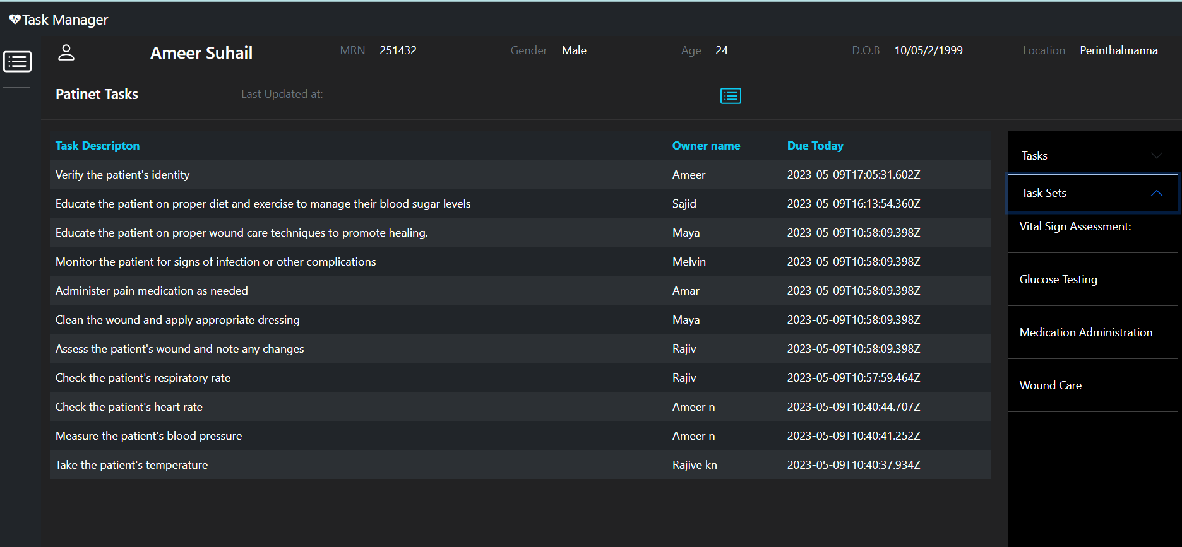

2.Backend

Query to fetch details from task and patient_task table.

Query to fetch task details using taskset id.

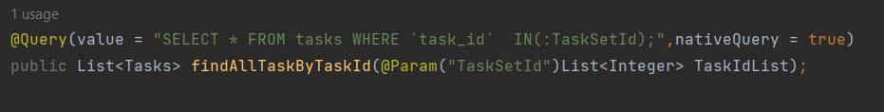
Query to fetch task details using a taskset id list
Query to fetch list of task id from task_set_mapping table using task set id to assign
the task sets
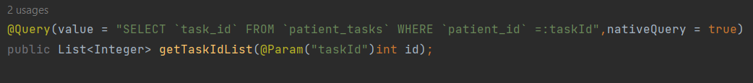
Query to fetch list of task id from patient_tasks table using task id to check duplicate entry of tasks

3.DataBase

ER Diagram

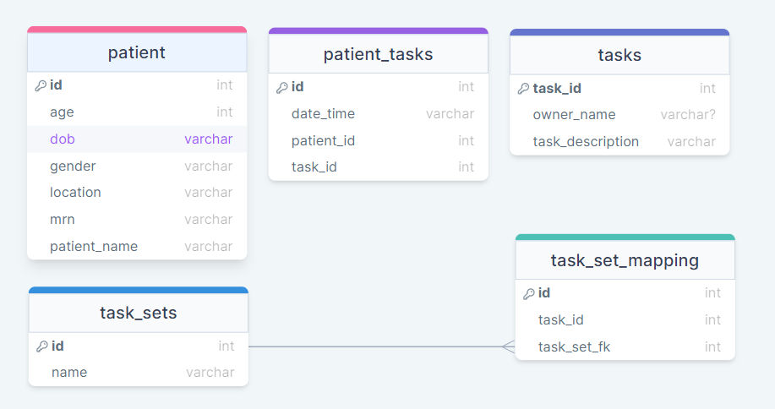

Tables

a.patient

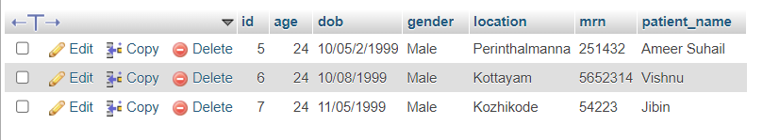
b.patient_tasks

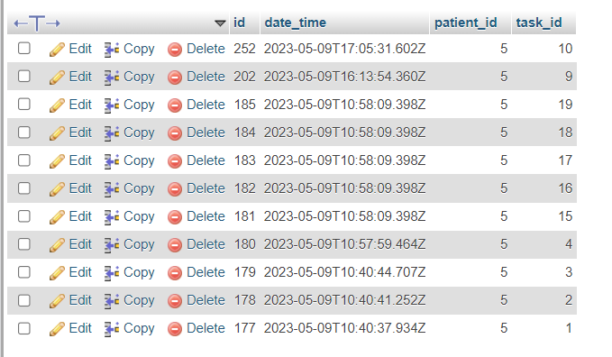
c.tasks

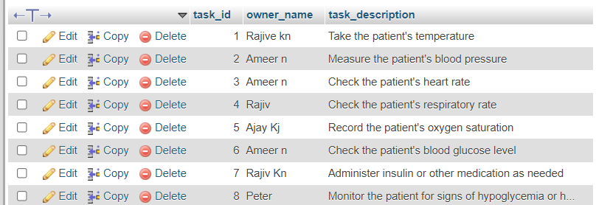
d.task_set
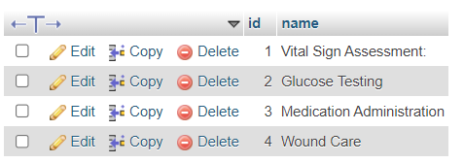

e.task_set_mapping
